

ISTANBUL TECHNICAL

**0**

**1**

UNIVERSITY

COMPUTER ENGINEERING

DIGITAL CIRCUITS LABORATORY

EXPERIMENT REPORT

EXPERIMENT NO: 6

EXPERIMENT NAME: USING BUS IN DIGITAL CIRCUITS

EXPERIMENT DATE : 05.04.2013

GROUP NO: 6

STUDENTS WHO DID THE EXPERIMENT:

Student no Name Surname

**040100113 MUSTAFA UÇAR**

**040100117 TUĞRUL YATAĞAN**

040100124 EMRE GÖKREM

ASSISTANT NAME WHO ASSISTED THE EXPERIMENT: NEZİHA AKALIN

1- )

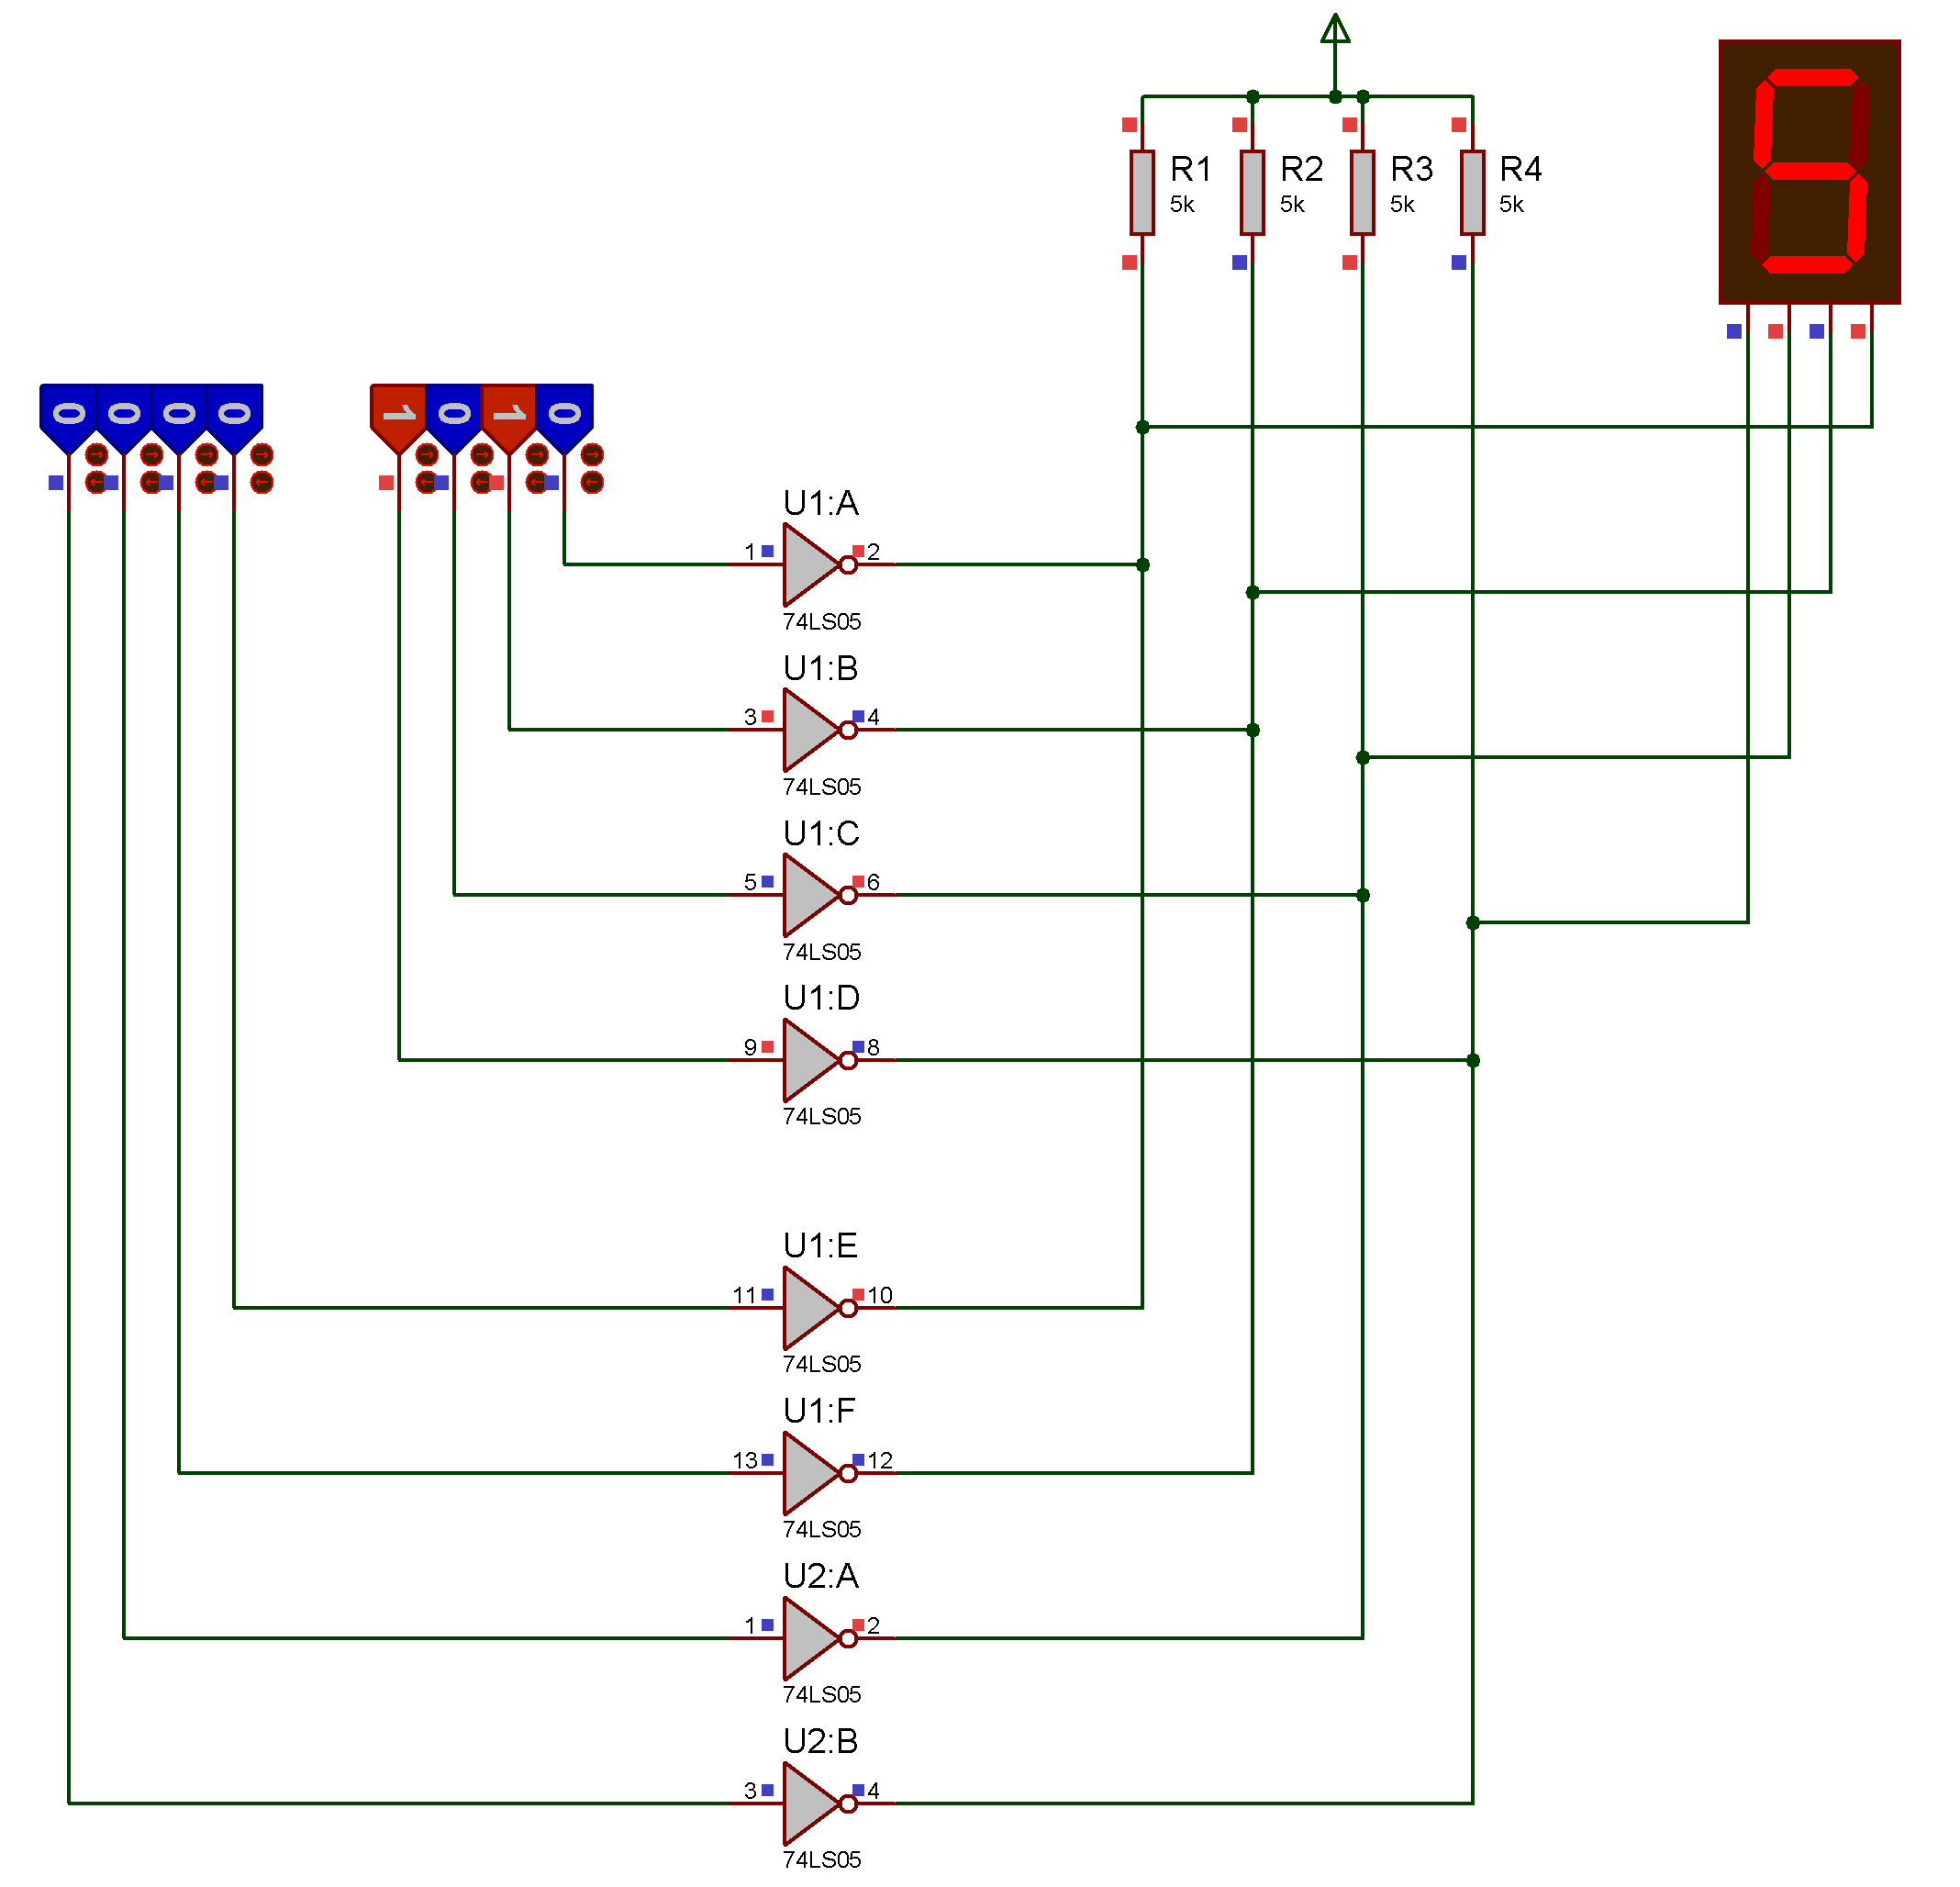

Rc(alt)= 4,2/ (8-0,4*N) 🡪 N=1 🡪 Rc(alt) = 0.552 ohm

Rc(üst)=3/(0,1*K+0,02*N) 🡪 K = 2 🡪 Rc(üst) = 13.63 ohm

When atleast one of outputs is logic 0, and then Vcc point ties to the ground. So we obtain a passive driver.

**2- )**

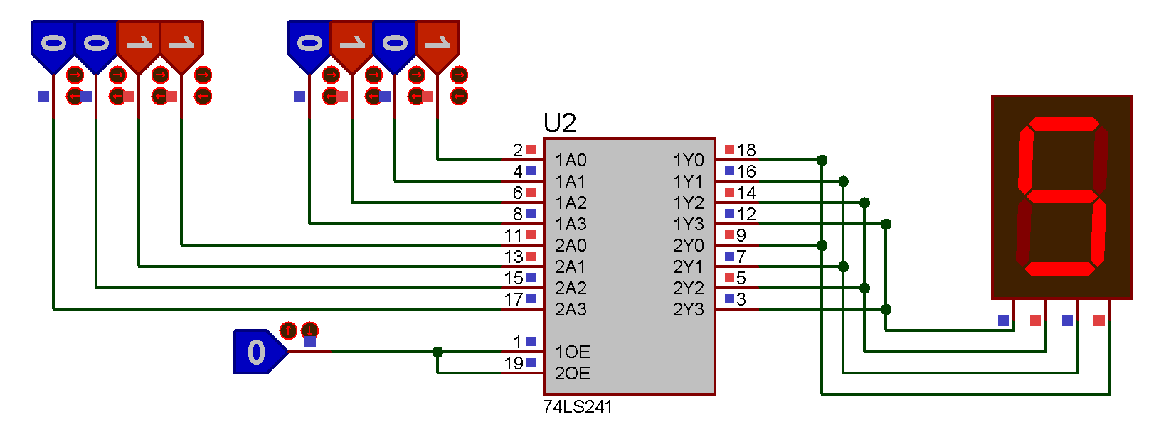

When inputs are entered to the 3-state buffers, only one of them is allowed to pass (high or low).

**3 - )**

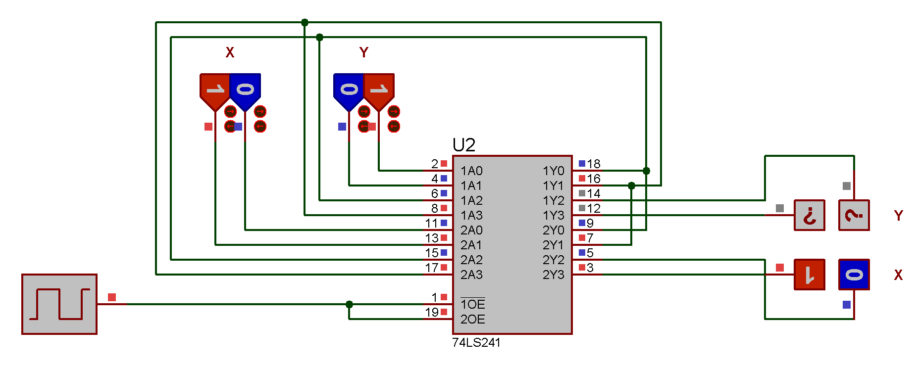

2-bit inputs are entered to the bus.

Choice between two of them is determined by clock signal.

While one input login is taking clock, other one is taking invert of clock. Depends on the clock signals value, only one of the inputs is allowed to pass.

**4- )**

a-)

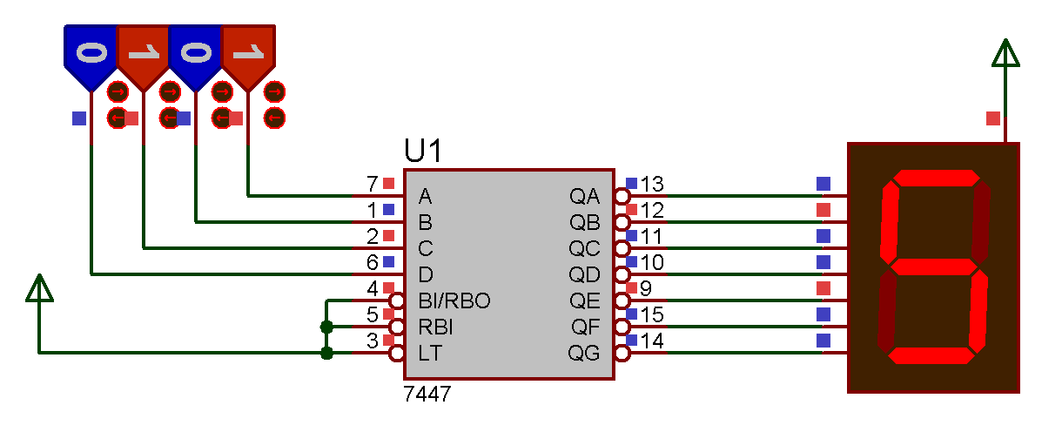

b-)

